Name: ______________________________________ | Date: ___________________

Investigating Surface Interactions

You saw that when the spring-launched cart made contact with the box it pushed the box forward. Changing the mass or the speed of the cart affected how far the box was pushed. Even though the cart was applying a force to the box when it was in contact with it, the box and cart always eventually came to a stop.

What are some everyday phenomena where objects seem to stop on their own after being put into motion?

What causes all these moving objects to eventually come to a stop?

Just like an object coming to a stop, it can also be harder to get different objects on different surfaces to start moving. As we have found with objects of different masses when we apply a force, it can take more force to get some objects moving. There seems to be something about the object interacting with the surface that is causing this to happen.

Use the materials your teacher sent home with you to carry out an investigation to figure out why some objects start and stop moving on some surfaces easier than others. You will use the rubber band to measure the amount of force it takes to pull a shoe across a surface. If the rubber band has to stretch more, then more force is being applied. If the rubber band stretches less, then less force is being applied. Use a ruler (or fold up the last page of this handout to use the paper ruler provided on it) to measure how far you have to pull the rubber band in the investigations you will carry out on the next page.

Investigation Procedure

Get a ruler or use the one on the last page of this handout.
Pick any shoe in your house that has shoe laces or a loop. Take the rubber band and create a knot called a cow hitch knot by looping the rubber band around the shoe string and putting one end of the rubber band through the rubber band loop. You have now attached a rubber band force detector to your shoe. | 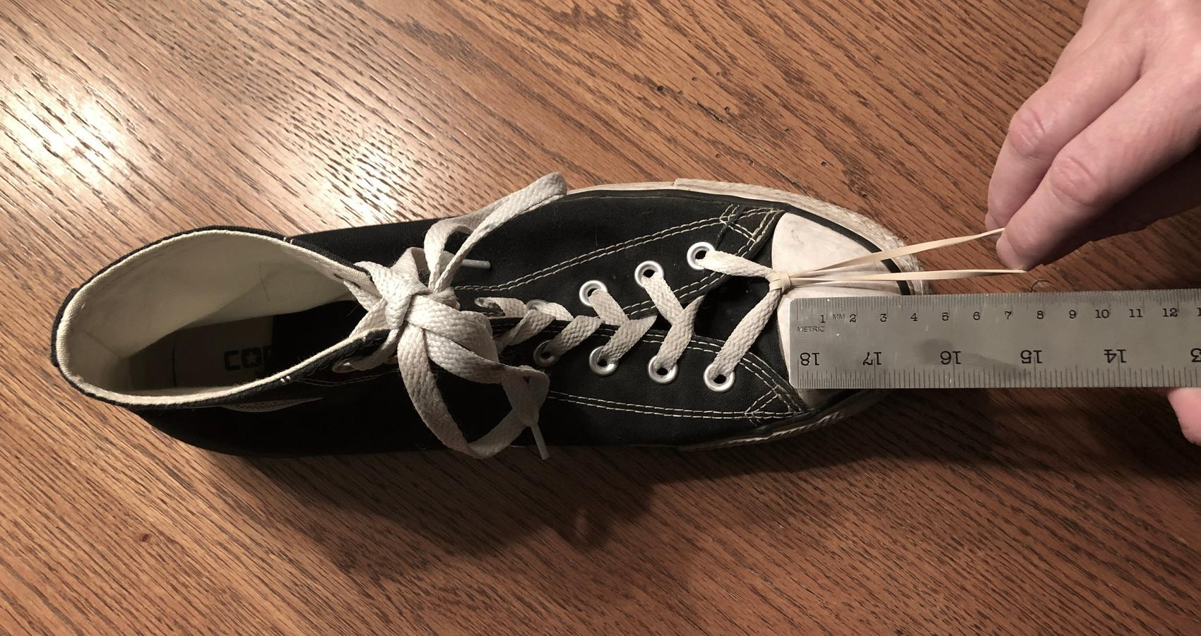
Pick any surface in or around your house. The surface could be carpet, wood, tile, grass, concrete, or some other surface. It is your choice. Place your shoe with the rubber band tied to it on the surface.
Hook one finger of one hand under the end of the rubber band. Start to pull gently on the rubber band. Hold a ruler a little to the side of the rubber band with your other hand so you can measure how far you stretch the rubber band before the shoe will move. | 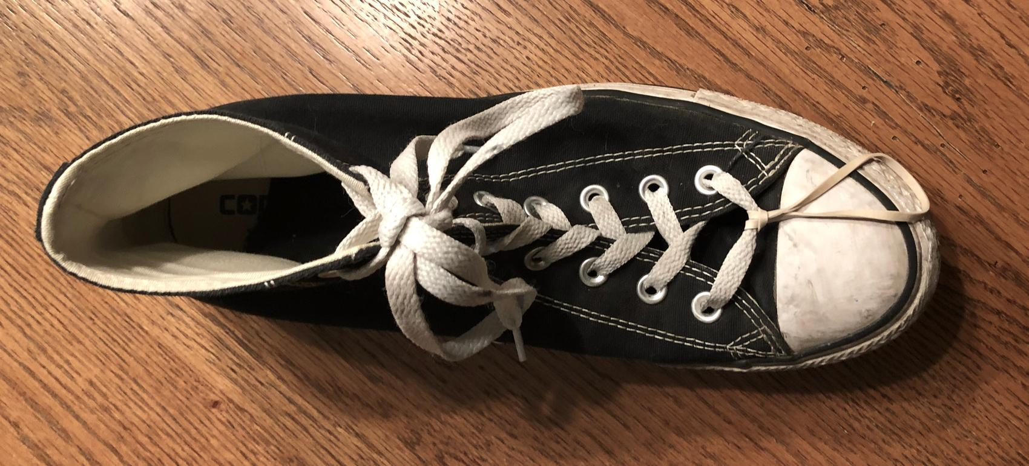
Record in the table below the distance the rubber band stretched before the shoe moved.
Investigate four different surfaces. Keep track of how far the rubber band stretches for each surface.

Shoe and Surface Investigation Data Table
 | Surface #1 | Surface #2 | Surface #3 | Surface #4
Description of the surface tested
How far the rubber band stretched before the shoe moved (cm)

Making Sense of Your Results
You probably noticed that in some cases the rubber band stretched more than others, and some surfaces felt like they required more force to move the shoe across them. Look at those surfaces. What about those surfaces would cause the rubber band to stretch further or make the shoe harder to pull? What do you think is happening between the surface and the shoe that more force would be needed to move the shoe?

Do you think the type of shoe matters? Why or why not?

Imagine you took the shoe you tested and launched it from a spring launcher with an equal amount of kinetic energy but changed the surface it slid across each time. On which of the surfaces you tested would it slide the furthest distance before coming to a stop? Why?

On which of the surfaces you tested would it slide the least distance before coming to a stop?

The cart and box also made contact with a surface as they traveled down the track. How do your results from this investigation help support the argument that there are similar contact forces between the box and the track as it slides down the track?

How would this contact force affect the kinetic energy of the box over time?

